SNARKY DOORBELL

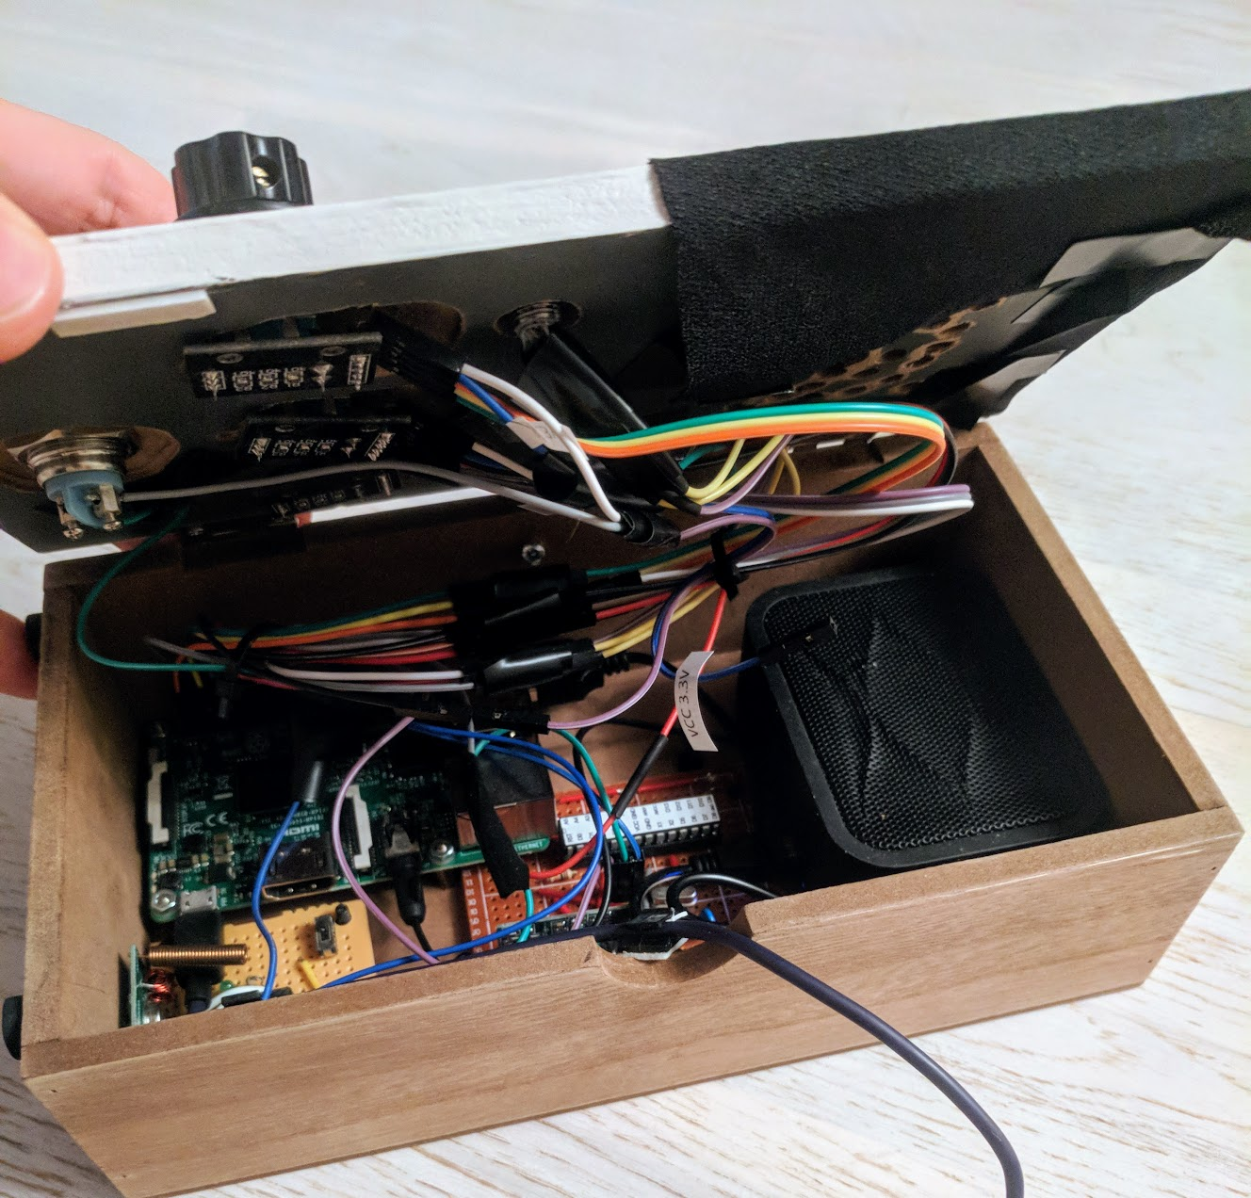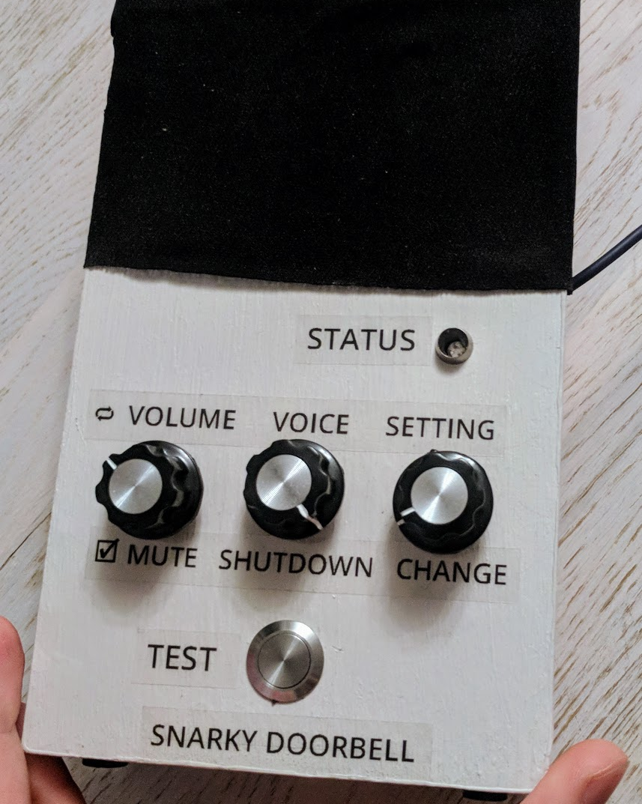

A doorbell that does more than just “ding-dong”: it has ATTITUDE.

- Custom-built Raspi / Arduino hardware
- Integrated with the original office doorbell
- Front-panel controls allow to adjust volume, voice and language
- Built in HTTP API server @ current dynamic IP (100.71.137.139:80)
- Custom voice personas

Currently alpha-testing :)

Project info
Code in GitHub: TBA
Build blog post: TBA
Making of video: TBA
Contact: ando@sqroot.eu

SNARKY DOORBELL USER MANUAL

Turning ON
Apply power via the integrated USB cable. Raspi will boot and automatically start systemd services for the API webserver and RF doorbell receiver. The doorbell will say when it has booted (~45sec) and ready.
Turning OFF
Press the (middle) SHUTDOWN button once. The status LED will change RED, wait until it turns OFF, then remove power. Do NOT remove power without properly shutting the device down.

Accessing the HTTP API
Locate the dynamic IP of the device from the WiFi network
(nmap -sP ‘100.xx.xxx.*’) and navigate to it using a web browser. API doc is presented there.

Controls
- VOLUME
  - Turn: adjust volume
  - Press: mute ON / OFF
- VOICE
  - Turn: change active voice persona
  - Press: initiate device shutdown
- SETTINGS
  - Turn: select a setting to change
  - Press: change the setting value
- TEST
  - Press: simulate a doorbell ring
- STATUS
  - Green: All OK, waiting for someone to ring the doorbell
  - Blue: Currently ringing
  - Red: Currently shutting down
  - Multicolor: booting up
  - OFF: Safe to remove power

Send bug reports, feedback and complaints to ando@sqroot.eu.

